ASSIGNMENT 5

**Q1-**

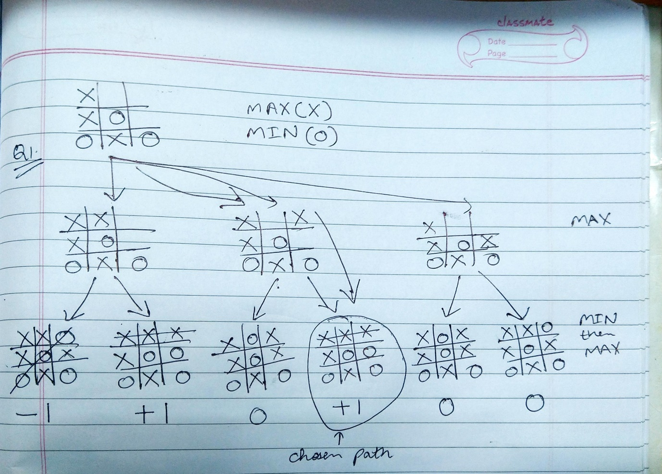

**Q2-**

**SEND + MORE = MONEY**

**5 4 3 2 1**

**S E N D**

**+ M O R E**

**c3 c2 c1**

**----------------------**

**M O N E Y**

**1. From Column 5, M=1, since it is only carry-over possible from sum of 2**

**single digit number in column 4.**

**2. To produce a carry from column 4 to column 5 'S + M' is atleast 9 so**

**'S=8or9' so 'S+M=9or10' & so 'O = 0 or 1'. But 'M=1', so 'O = 0'.**

**3. If there is carry from Column 3 to 4 then 'E=9' & so 'N=0'. But**

**'O = 0' so there is no carry & 'S=9' & 'c3=0'.**

**4. If there is no carry from column 2 to 3 then 'E=N' which is**

**impossible, therefore there is carry & 'N=E+1' & 'c2=1'.**

**5. If there is carry from column 1 to 2 then 'N+R=E mod 10' & 'N=E+1'**

**so 'E+1+R=E mod 10', so 'R=9' but 'S=9', so there must be carry**

**from column 1 to 2. Therefore 'c1=1' & 'R=8'.**

**6. To produce carry 'c1=1' from column 1 to 2, we must have 'D+E=10+Y'**

**as Y cannot be 0/1 so D+E is atleast 12. As D is atmost 7 & E is**

**atleast 5 (D cannot be 8 or 9 as it is already assigned). N is atmost 7**

**& 'N=E+1' so 'E=5or6'.**

**7. If E were 6 & D+E atleast 12 then D would be 7, but 'N=E+1' & N would**

**also be 7 which is impossible. Therefore 'E=5' & 'N=6'.**

**8. D+E is atleast 12 for that we get 'D=7' & 'Y=2'.**

**SOLUTION:**

**9 5 6 7**

**+ 1 0 8 5**

**-----------------**

**1 0 6 5 2**

**VALUES:**

**S=9**

**E=5**

**N=6**

**D=7**

**M=1**

**O=0**

**R=8**

**Y=2**

**Q3-**

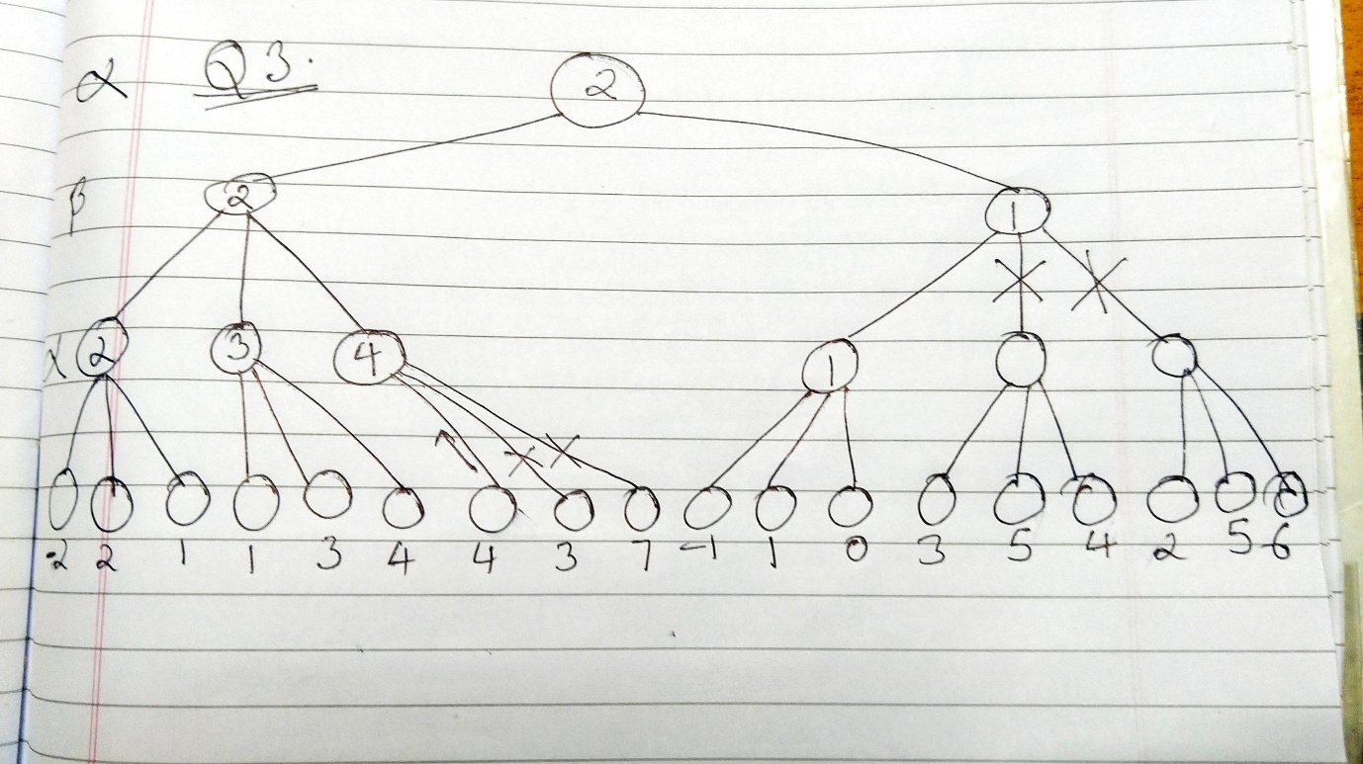

**Q4-**

